Logical functions & Lookup

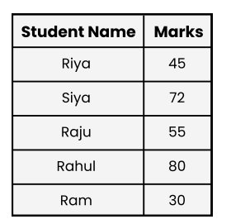
Q1. Write a formula to check if the marks in cell B2 are greater than or equal to 40. If yes, return , otherwise . B2 "Pass" "Fail”.

Ans1. = IF(B2>=40, "Pass", "Fail")

Q2 . A company gives a bonus if sales are above 40,000 and attendance is greater than or equal to 90%. Write a formula to calculate whether the employee will get a bonus or not.
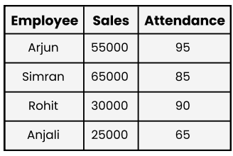
Ans2. =IF(AND(B2>40000, C2>=90), "Bonus", "No Bonus")

Q3. Write a nested IF formula: If marks in are ≥ 90 → , ≥ 75 → , ≥ 50 → , otherwise . B2 "A" "B" "C" "Fail


Ans3. =IF(B2>=90, "A", IF(B2>=75, "B", IF(B2>=50, "C", "Fail")))

Q4. Find the Department of Employee ID = E103. Also explain which LOOKUP function is used and why?
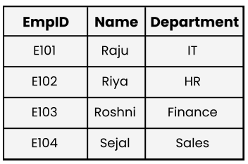

Ans4. =VLOOKUP(A4,A1:C5,3)
(Why we need lookup function in excel and what is the use of this formula Because the department for Employee ID E103 is Marketing. This is found using VLOOKUP because the data is arranged in vertical columns, allowing the function to search for the ID and pull the corresponding department from the right)
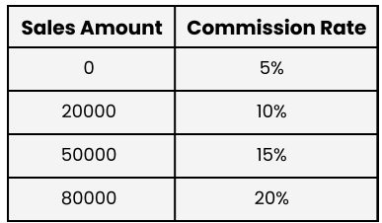
Q5. A company has set the following commission structure for its sales team:

Ans5. =VLOOKUP(45000, A9:B13, 2, TRUE)
0.1% Commission
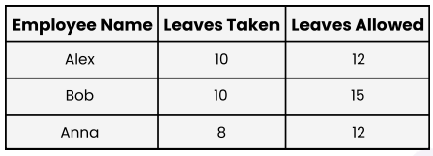
Q6. The HR department maintains the following leave records of employees Bonus or not .

Write an IF function to check whether an employee has Exceeded their allowed leave balance. If Leaves Taken > Allowed Leaves, display "Exceeded". Otherwise, display "OK"
Ans6. =IF(B2 > C2, “Exceed”, “Ok”)
The all answer is written by “OK
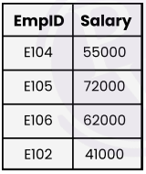
Q7. Find the salary of EmpID = E105 using INDEX-MATCH Function.

Ans7. =INDEX(B2:B5, MATCH("E105", A2:A5, 0))
(This formula given you 72000)
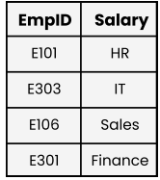
Q8. Use the XLOOKUP function to find the Department of the employee with Emp ID = E303.

Ans8. =XLOOKUP(A47,A45:A49,B45:B49)
This formula givens you (IT)

Drive Link:- https://drive.google.com/drive/folders/1ZlFjacMcn7A-Gi0Qmzbq18jmXQvYIuqH?usp=sharing

